**CORRECTING COGI ERRORS – REPRODUCING DEMAND & ORDERS FOR ITEMS**

1. Enter Order # in COOIS (or COHV) and Execute

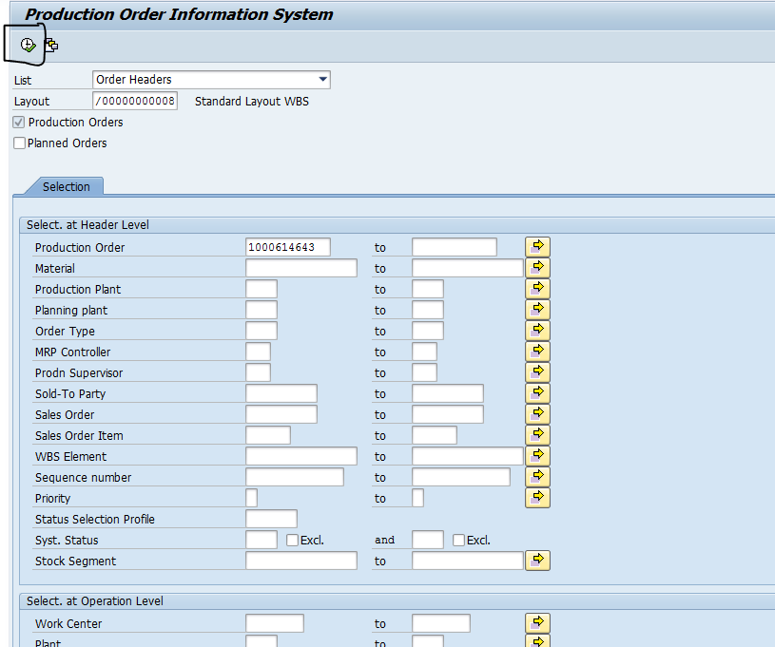

1. Click on the pencil on the icon bar. This will take you into the order with change powers



1. Click on Operation Overview Icon. This will take you into Operation Overview

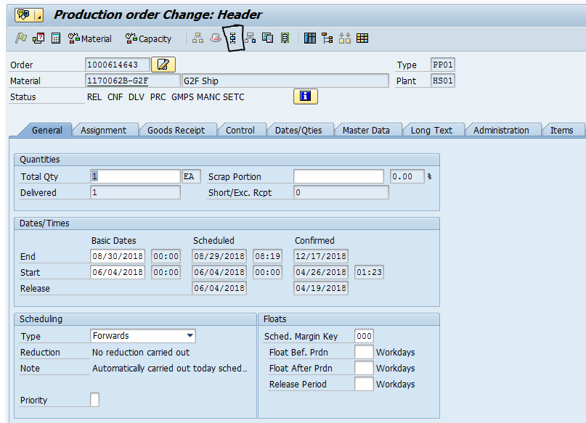

1. At the bottom of the operations, enter in the following info (you do not need to highlight the line)
   1. Control Key = ZP01
   2. Std Text = 2061

Hit the **Enter Key**

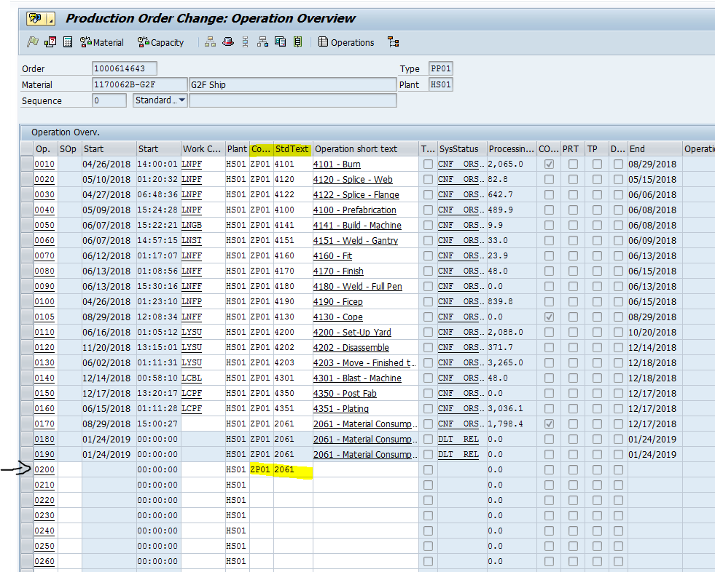

1. Keep Hitting **the Enter Key** to go through all the tabs

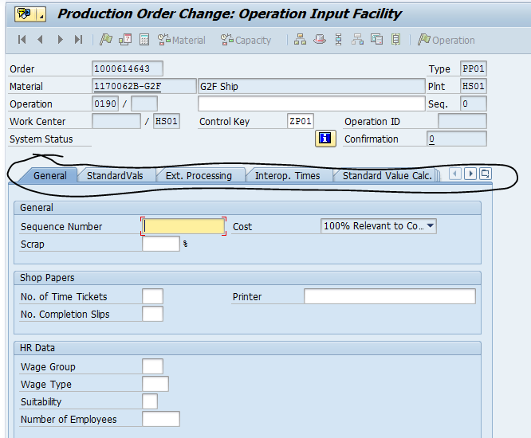

1. Make note of the Operation #. You will need it in the **COMPONENT OVERVIEW** screen.

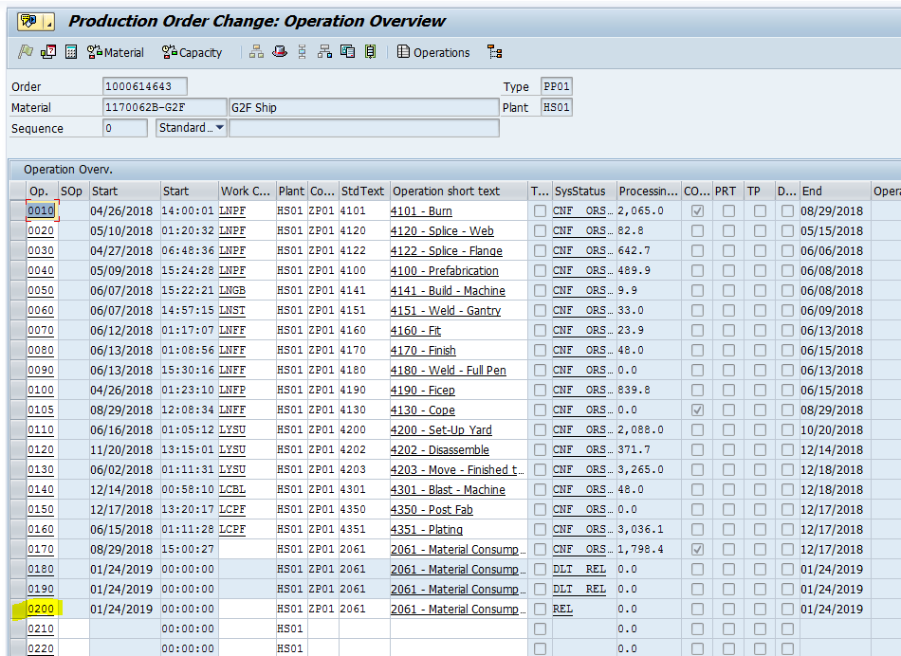

1. Click on the **COMPONENT OVERVIEW** icon. This will take you to the components.

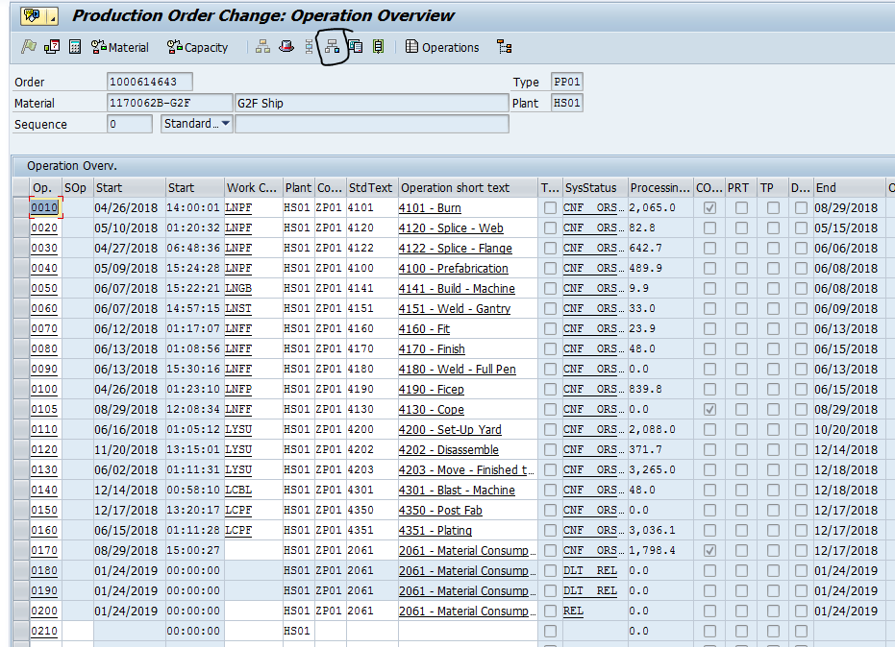

1. In the Open rows at the bottom, add in the following:
   1. material # from the COGI report that we need to create a planned order for
   2. Qty for the material
   3. Unit of measure (will usually be each)
   4. Item Category = L Stock Item
   5. Operation = new line that was just added
   6. Plant = Plant code HS01=Lancaster HS02=Williamsport
   7. Click to get the checkmark in the backflush column
   8. Enter 2 in Special Stock if this is for MM on a WBS. Leave blank if the component is plant stock (MM starts with 50- or 9-)

Hit the Enter Key

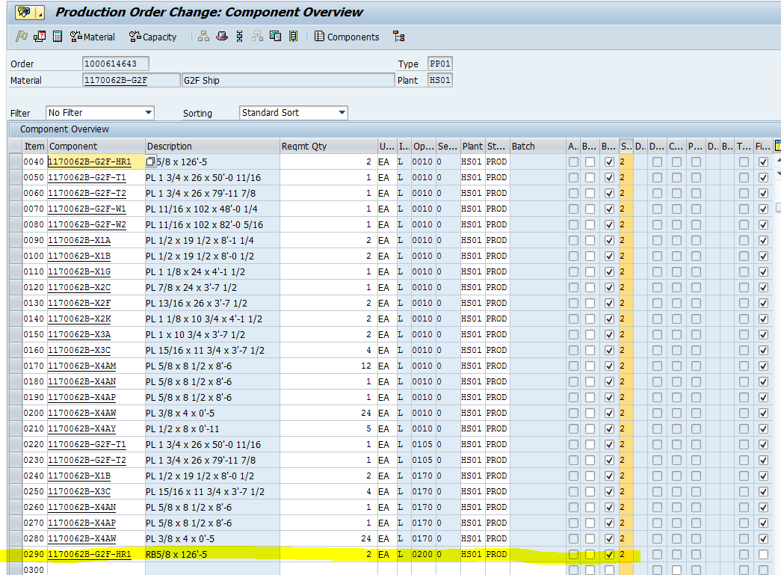

1. Click the Save Icon at the top

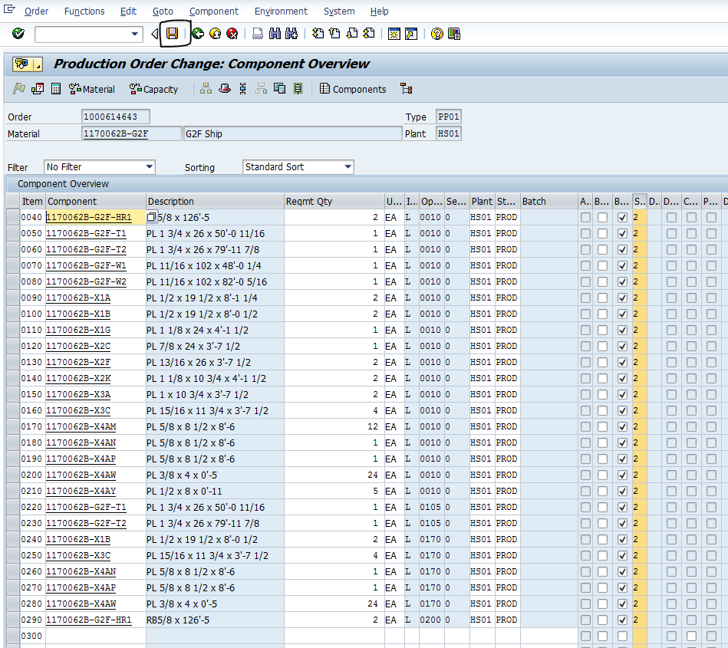

1. You will probably get a message about Error calculating costs. It will ask if you still want to save. Click the Yes button.

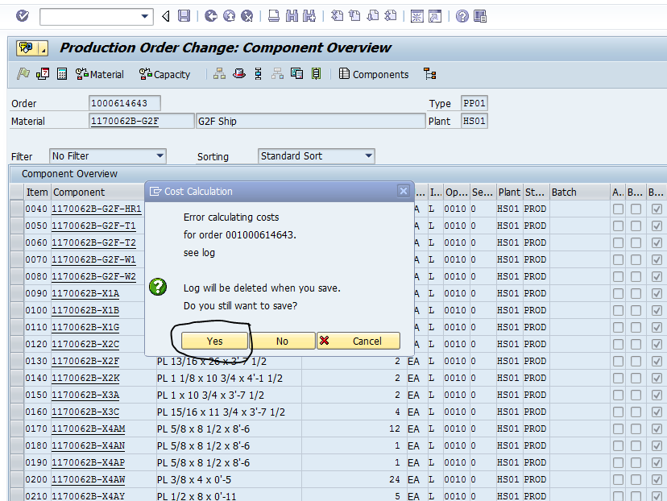

1. Run MRP in **MD51**. If you don’t have access, ask Jere Vickers or Ben Lakis to run MRP for project. They need to know which project & the shipment level that the Order is in. They can run on just on the shipment level as well.
   1. Enter in WBS for Project Def.
   2. This is optional. This is where you can put in the shipment WBS element
   3. MRP Control Parameters
      1. Create Purchase Req. = 1
      2. Planning Mode = 2
      3. SA Deliv. Sched = 3
      4. Scheduling = 2
   4. Process Control Parameters
      1. Click for Check Also Plan Unchanged Components
      2. Click Display material List

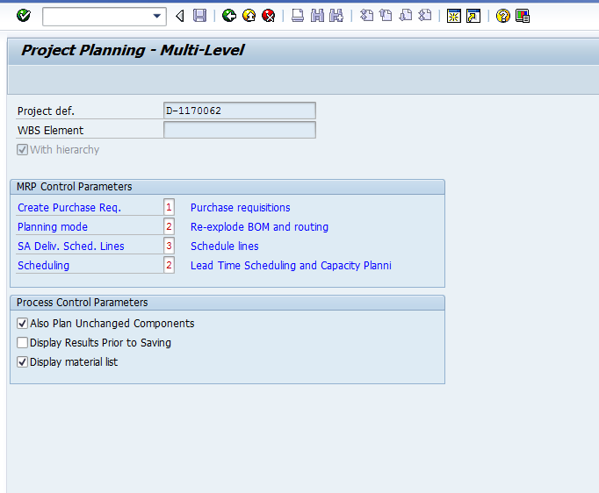

1. When done running, you will get report. Check to see that Planned Order was created.

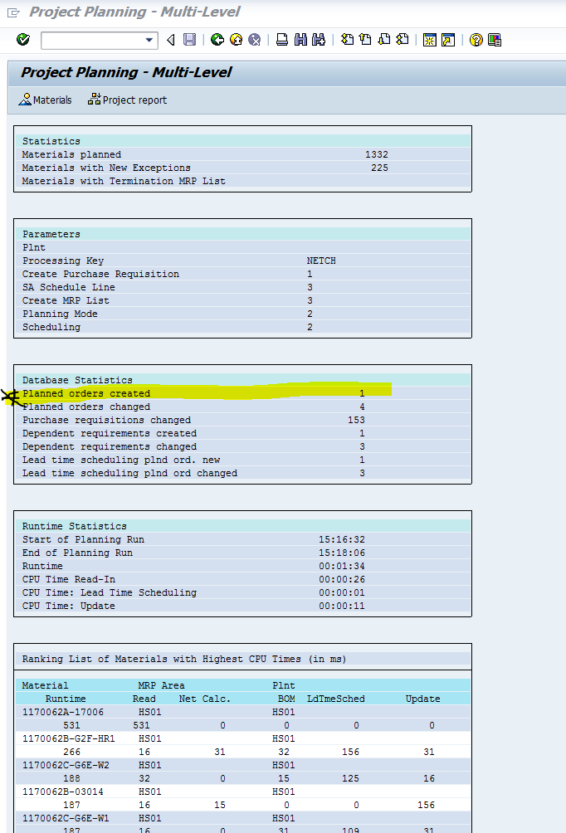

1. An alternate option to run MRP is to go into MD04. Enter in the material number you added to the component list. Click on Sng-item, Multi-lvl button

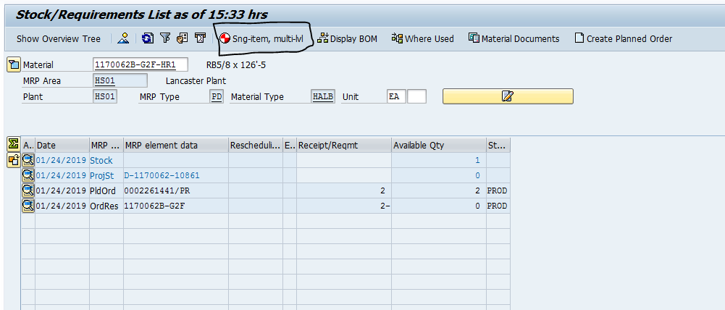

1. Convert the planned order to a production order. Go to MD04 and put in the component and plant Hit the Enter key.

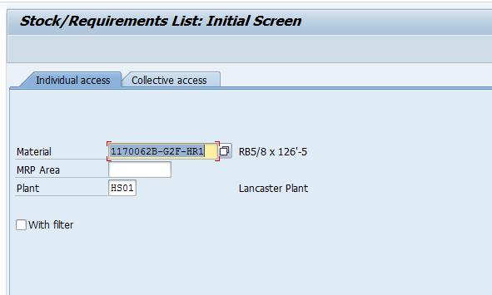

1. Double Click on the planned order. MRP element should say **PldOrd**

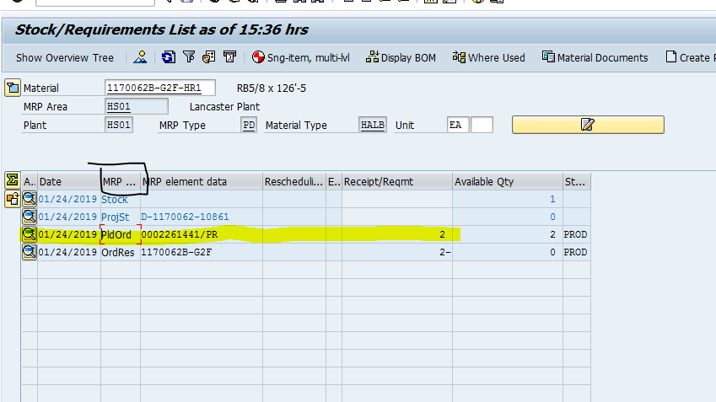

1. Click on -> Prod.Ord. Icon

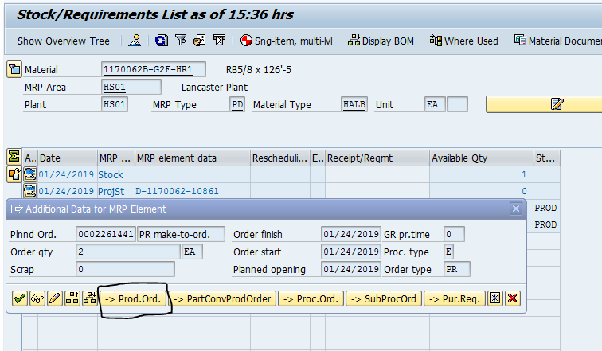

1. More stuff that I can’t write since I don’t have access to do a production order. You would then hit save and make note of the order
2. Go into **COHV** to Confirm the production order
   1. Click on Get Variant to select variant to confirm with

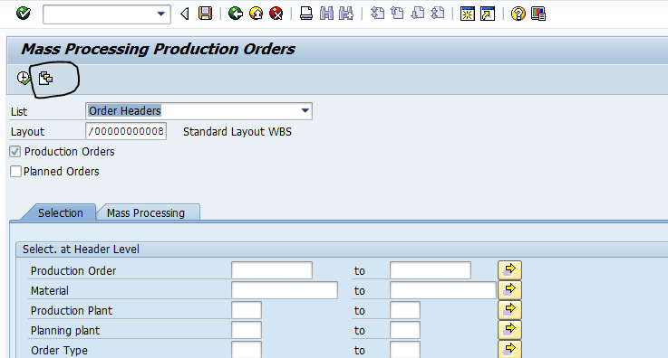

* 1. Clear the Created By field and click Execute

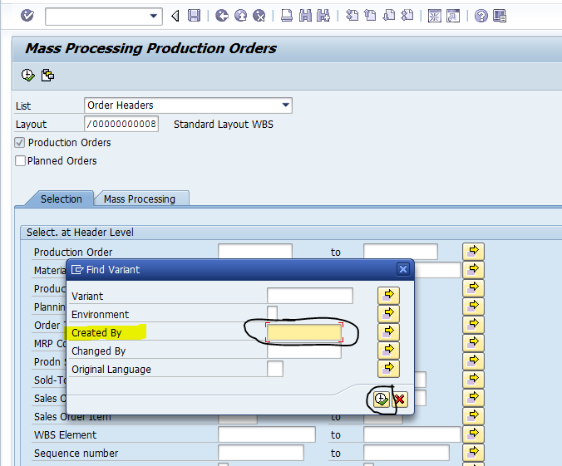

* 1. Select /PN1_CNF Variant by double clicking on it or selecting it and then clicking the Green Arrow button

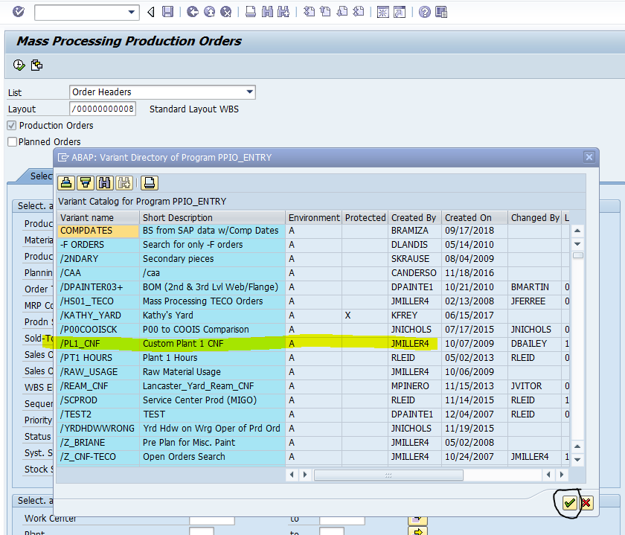

1. Enter in the Production Order(s) you want to confirm and click Execute

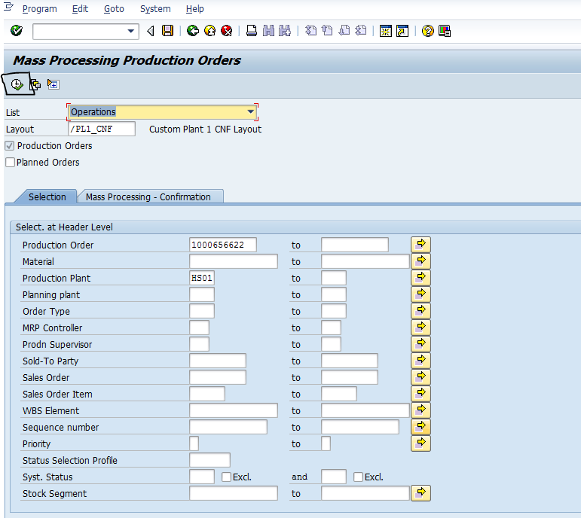

1. Select all the lines to confirm by clicking the Select All icon in the left corner by Order

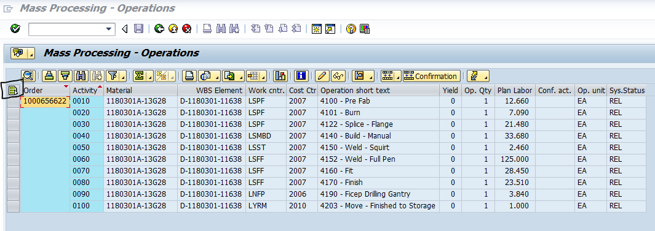

1. Click on Confirmation icon

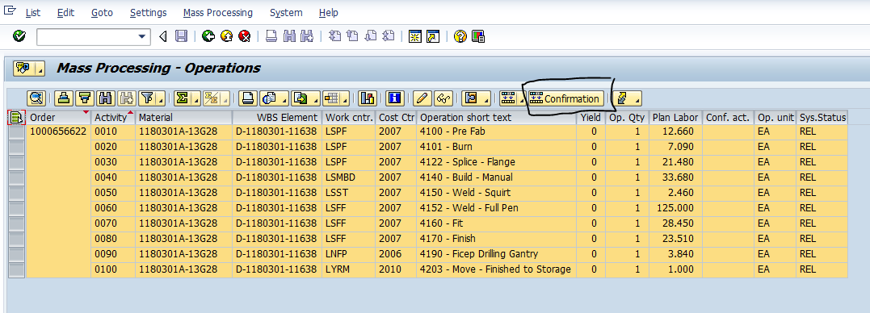

1. Fill in the following:
   1. Final Confirm. = X
   2. Enter in the yield = # of pieces you need to confirm
   3. Hit Enter key

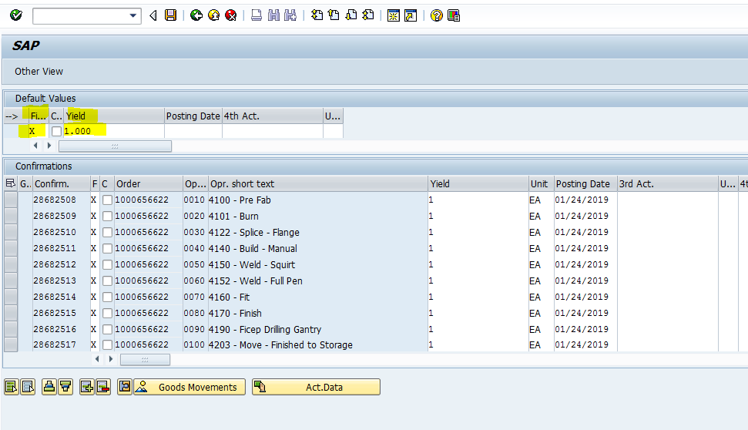

* 1. It will fill in the X for Final Confirm on all lines and enter in the yield on all lines. Take your mouse and SCROLL down past all the lines to make sure all lines have populated
  2. Click the Save icon

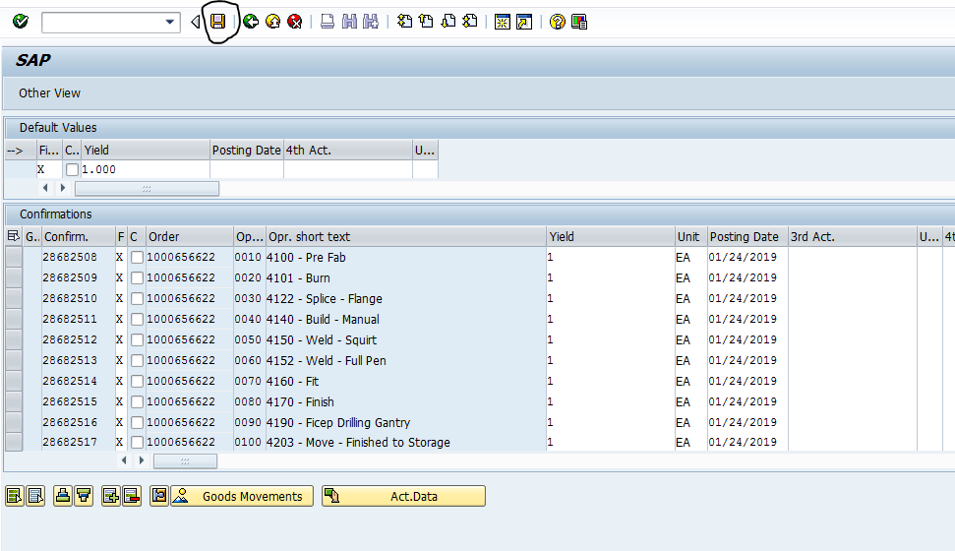

1. Check COGI report to make sure your newly created item did not error out due to not having a location. If so, clear the error.
2. If no error, or after the previous error has been cleared, then you should be able to clear your COGI error

**CONGRATULATIONS!!!! YOU DID IT!!!**